M2 API:
Callback URL response is different
API Endpoint :-https://dev.abdm.gov.in/api/hiecm/v3/token/generate-token
call back: SandBox
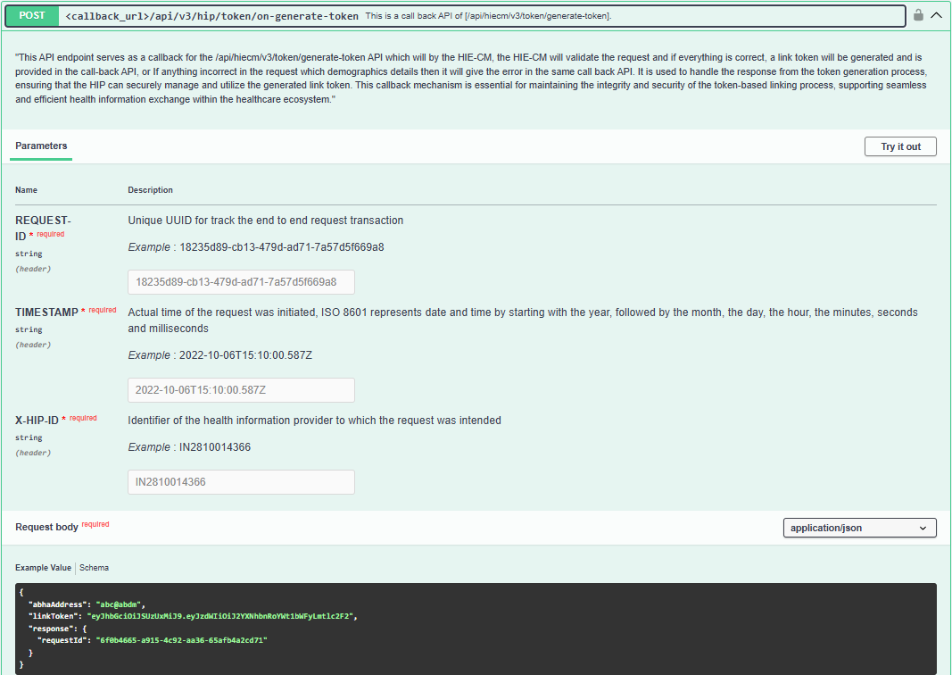
Callback URL:
2. Link on carecontext | ABDM Developer Portal
